Design a circuit using OPAMPs to produce

**Vo=2*V1 +3*V2+V3**,

where V1 and V2 and V3 are three positive input voltages and Vo is the output. Simulate your design for *V1=1, V2=2, and V3=1*.

# Simulation screenshots

**Circuit Diagram of OPAMP**

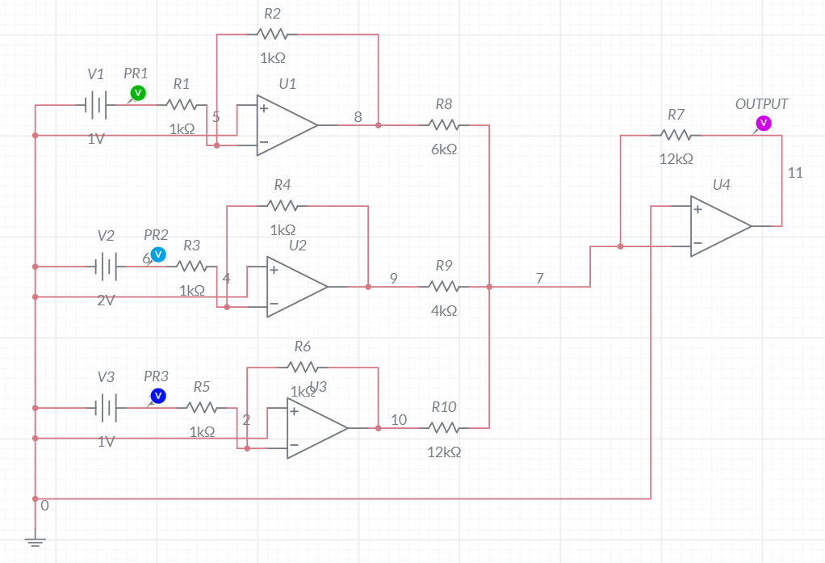

**Grapher Image**

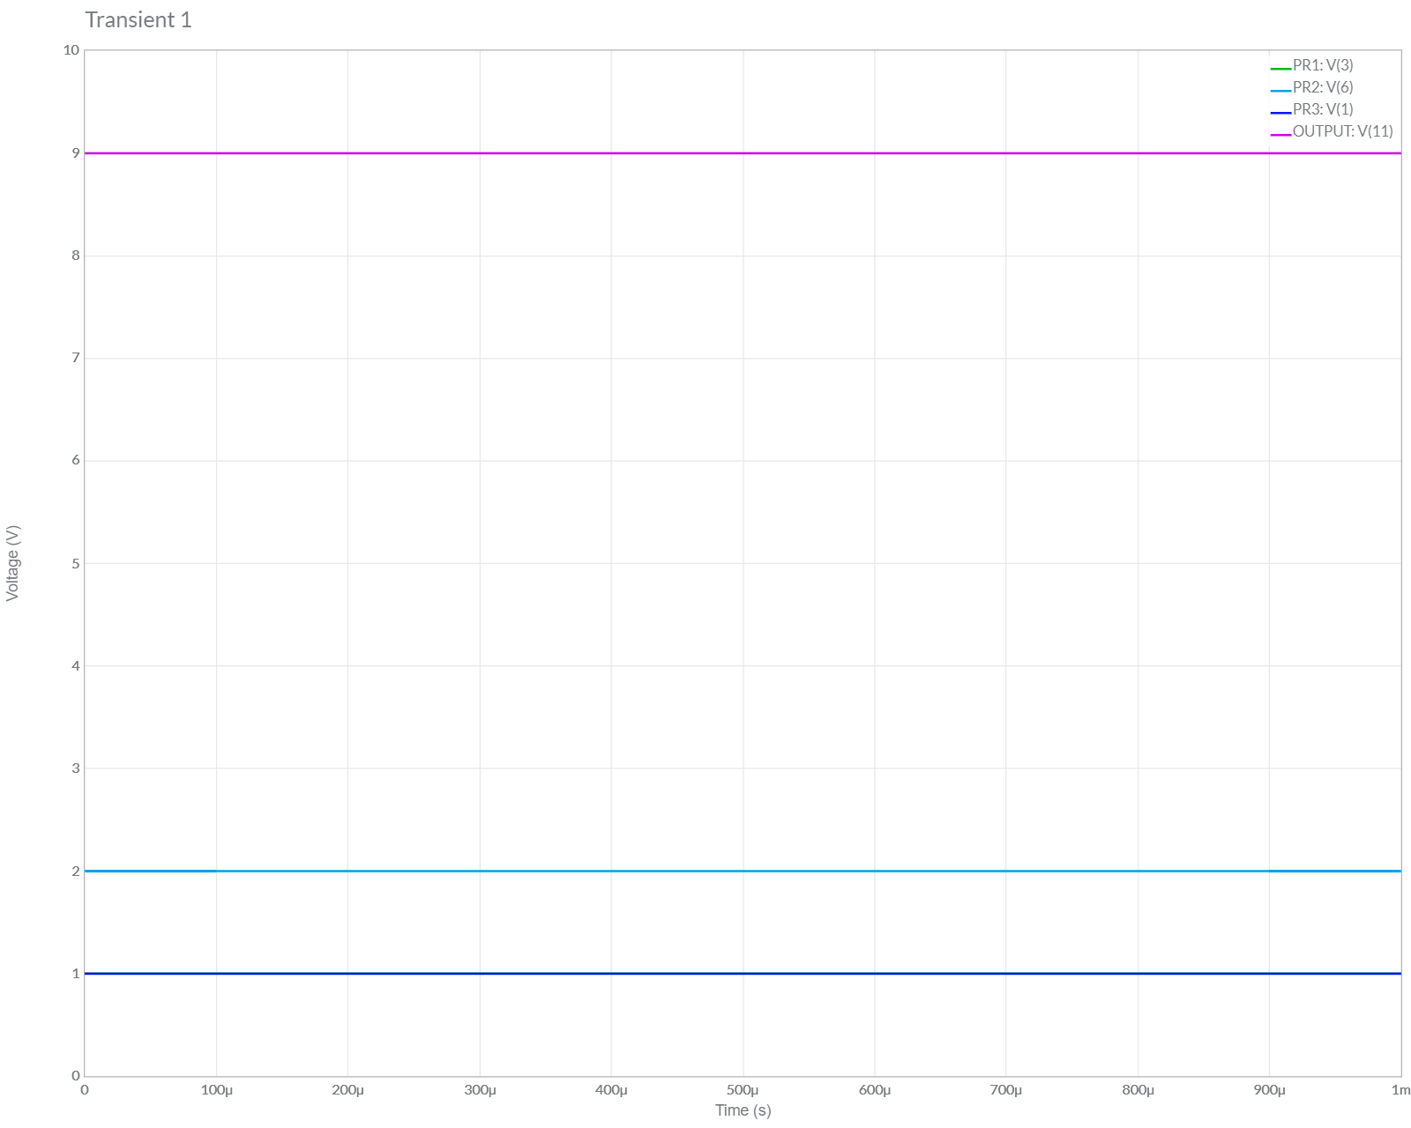

# Simulation screenshots

**Circuit Diagram of OPAMP [Optimized]**

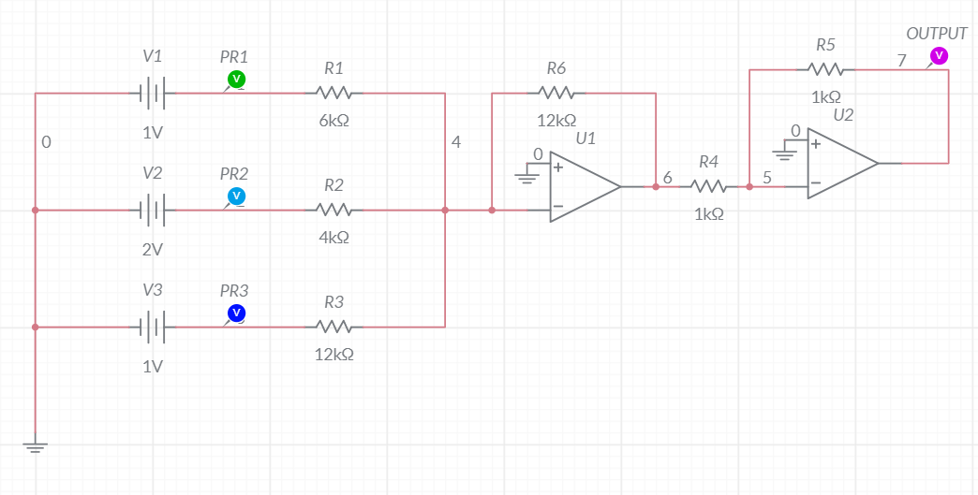

**Grapher Image [OPAMP Optimized Approach]**

